Amazon DeepRacer

1. Creating a model

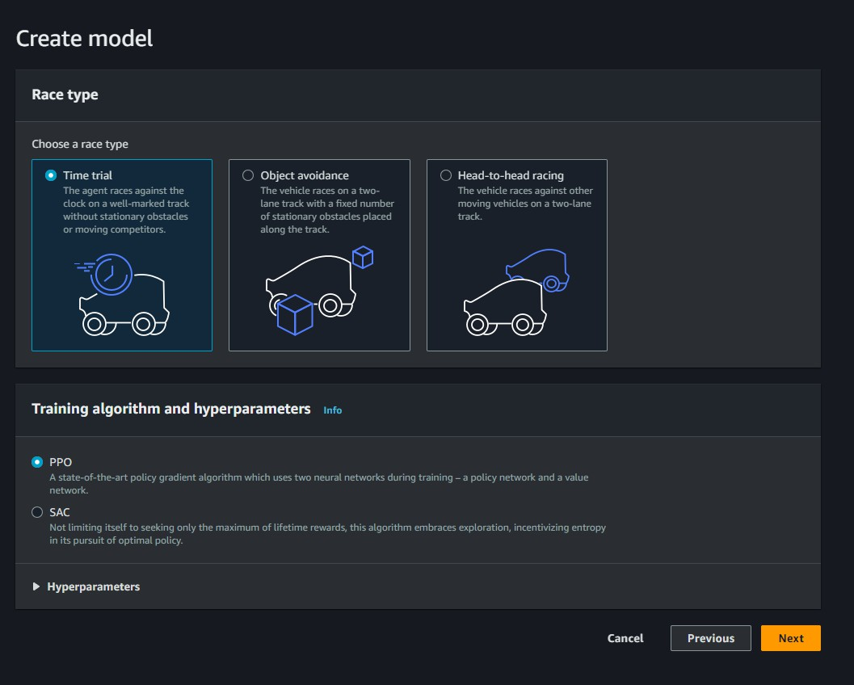

1. 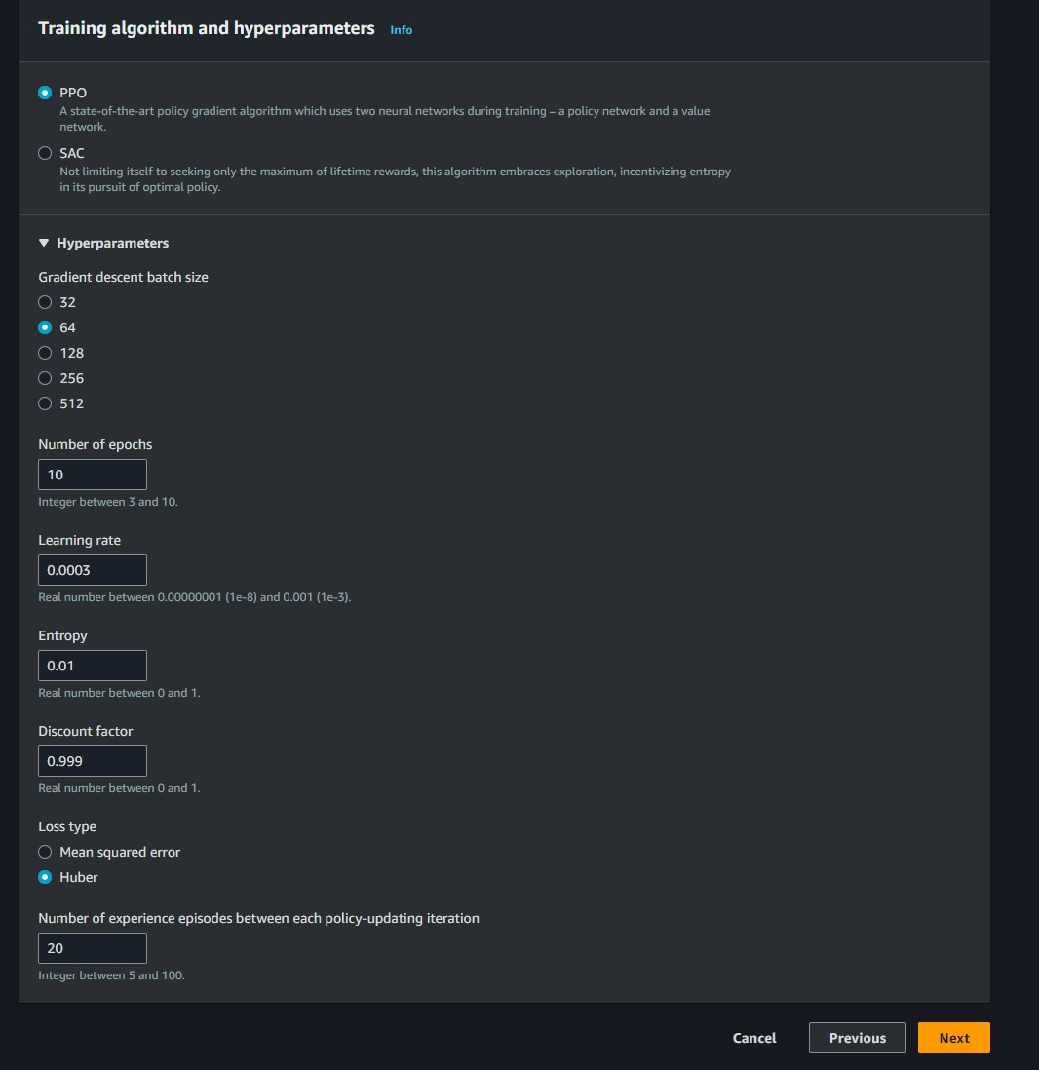Training algorithm and hyperparameters
2. 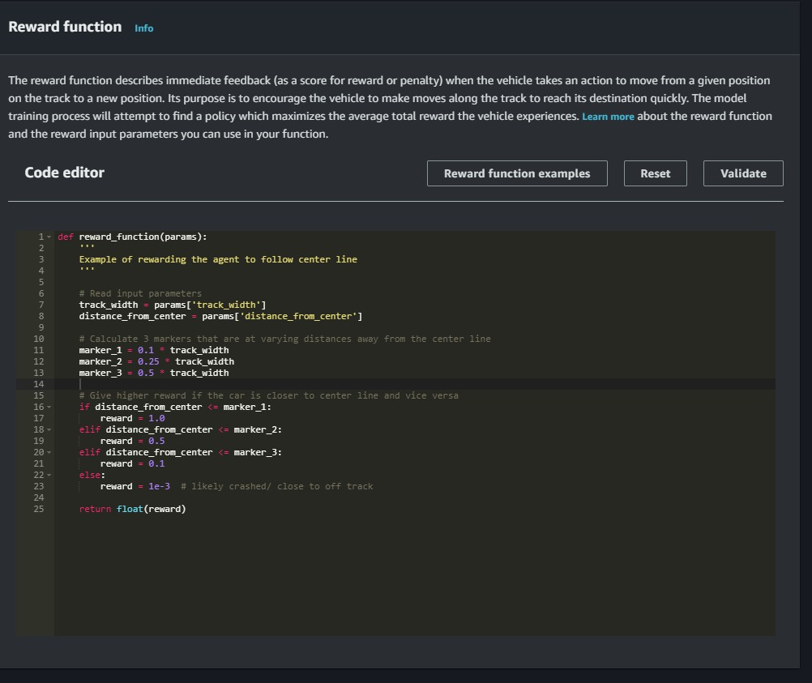Reward function
3. Training Configuration

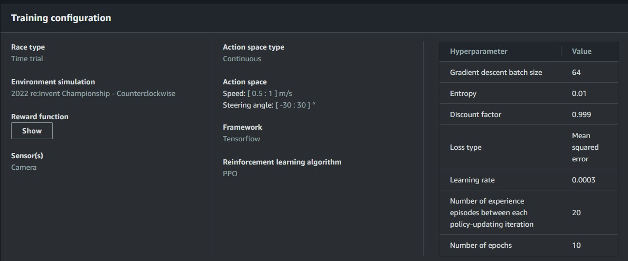

1. 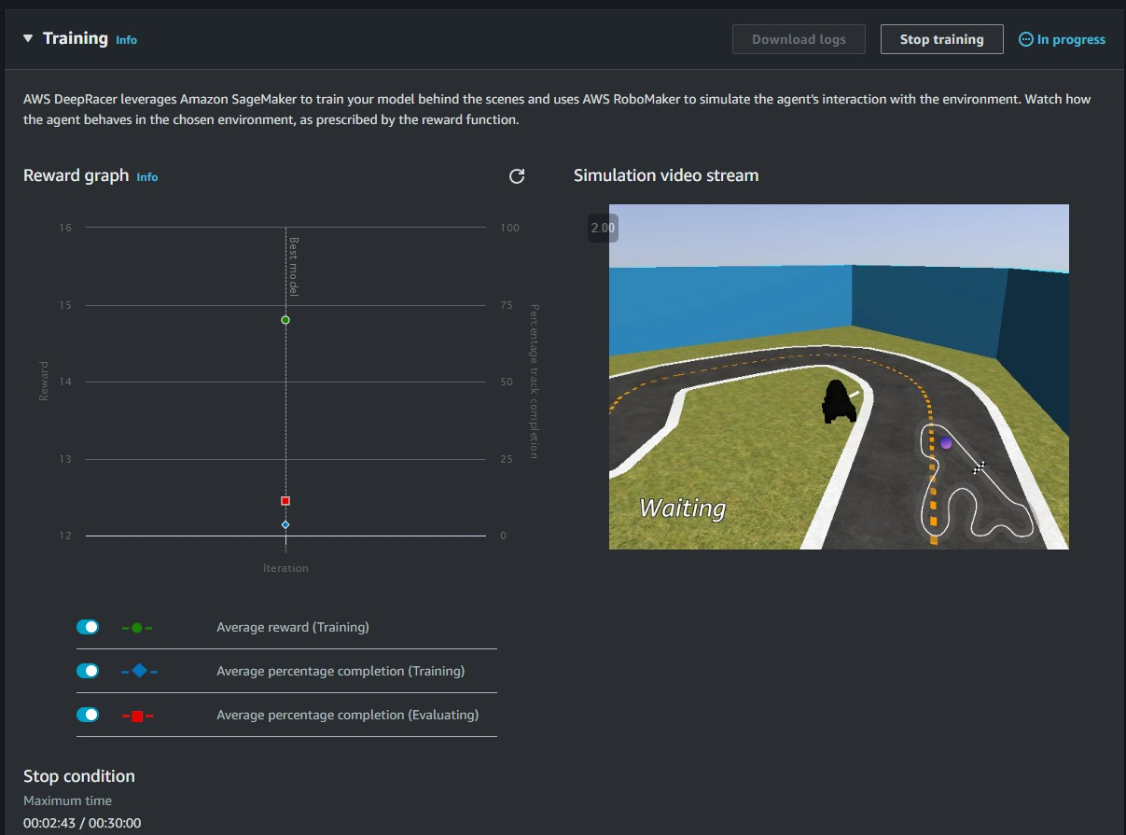Mid-Training
2. Video recording

[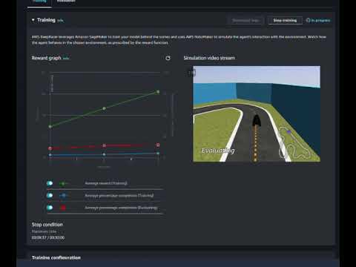](https://www.youtube.com/embed/RGwXGHxO9AQ?feature=oembed)

1. Training completed

